Name: ___________Christopher Guay_____________________

Please recreate the record store problem using two tables – One of those tables should be an “Artist” table the represents the recording artist. Please create a word document that contains your SQL and step-by-step process (be sure to show output from your selects as well as table describes, etc)

Using the record store example from last time. Please define a database that consists of two tables to hold all of the data. One of the table should be just for the artist

Note: Include a new artist (The Bee Gee’s) with no Records, CD’s or Singles in our inventory

Also Using SQL and JOIN’s, show the results from:

1. All of the product we have in inventory that is priced less than $20
   * Update the prices of all of the albums to $25.99 and re-run this query
2. All of the CD’s and Albums we have in Stock
3. All of the Artists for which we have no inventory listed (not zero quantity, we just never had any of their material in our store in the past)

(The SQL queries should list the Artist, the Name of the material (cd, single or album name) and the quantity in stock)

**Tables:**

Artists:

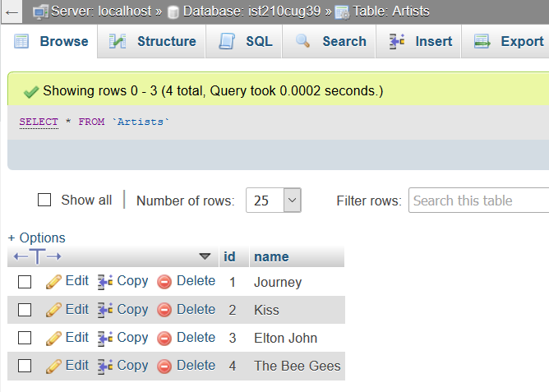

Records2:

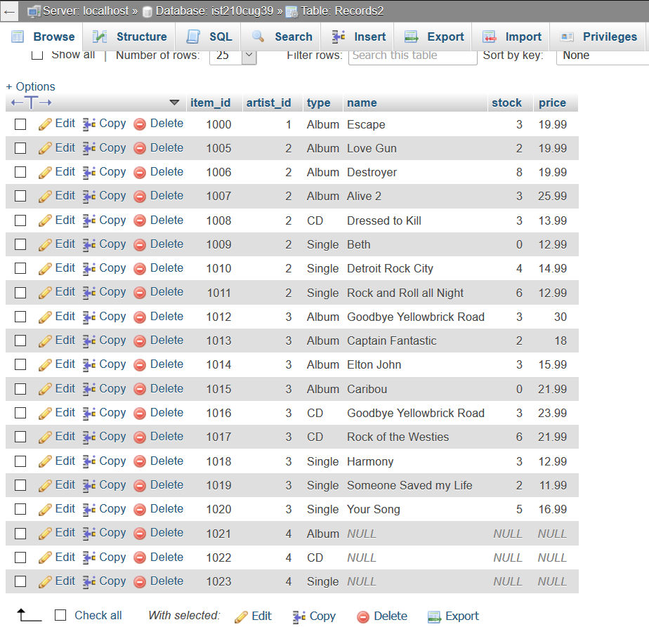

1. 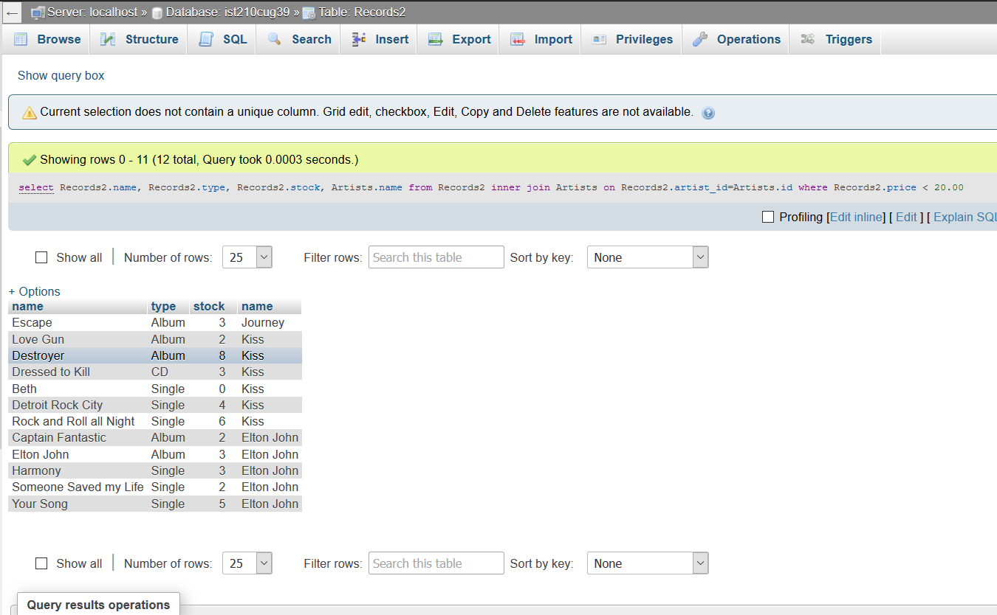
   1. 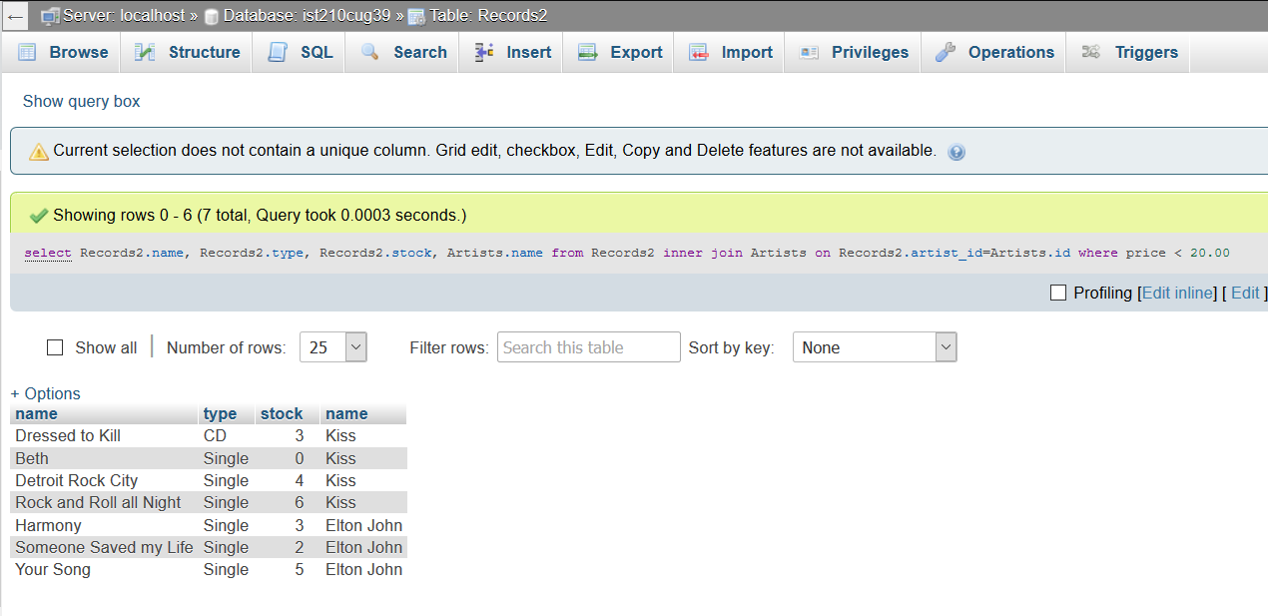
2. 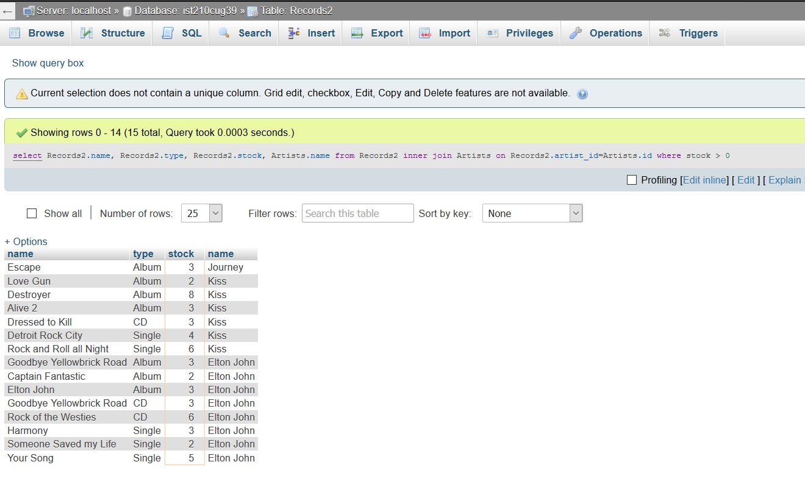
3. 